STUDENT PERFORMANCE ANALYTICS SYSTEM
A Python Mini Project Report for Python with AI
Student Name: Aditya Jain
Course: Python with AI
Institute / Course Provider: EWB Courses

Objective
In educational institutions, tracking and evaluating student academic progress across multiple subjects is essential for identifying top performers, supporting struggling learners, and understanding overall institutional performance. Manual record-keeping and calculation are time-consuming and prone to human error.
The primary objective of the Student Performance Analytics System is to automate the processing and evaluation of student academic records using Python. Specifically, the system aims to:
- Automate the ingestion and organization of student data from structured CSV files.
- Compute individual student aggregate totals and term averages across multiple core subjects.
- Apply standardized grading criteria and rigorous pass/fail evaluation rules.
- Perform robust statistical data analysis using NumPy to compute class-wide performance metrics.
- Generate actionable insights, including subject-wise performance averages and top-performing student rankings.

Technologies Used
The project is implemented using standard Python programming constructs and industry-standard data science libraries. Only tools and libraries actually utilized in the codebase are included below:
- Python: The core programming language utilized for application logic, control flow, functions, and file input/output operations.
- Pandas: A powerful data manipulation library used for loading tabular datasets into DataFrames, cleaning data, filtering records, and computing row-wise and column-wise aggregations.
- NumPy: A fundamental package for scientific computing in Python, utilized here for efficient numerical array calculations and statistical aggregations (such as mean, min, and max).

Dataset Description
The project utilizes a structured CSV dataset named students.csv containing exactly 20 student records. Each record captures essential administrative and academic attributes across five distinct subjects.
Dataset Attributes / Columns:
- Student_ID: A unique numeric identifier assigned to each student (ranging from 101 to 120).
- Name: The full name of the student.
- Department: The academic department or stream (e.g., CS, IT).
- science: Numerical marks obtained in Science (out of 100).
- Mathematics: Numerical marks obtained in Mathematics (out of 100).
- English: Numerical marks obtained in English (out of 100).
- Computer_Science: Numerical marks obtained in Computer Science (out of 100).
- History: Numerical marks obtained in History (out of 100).
- Attendance: The student's overall attendance percentage.

The file contains exactly 20 records and 9 columns, perfectly meeting the project guideline requirement of 15–20 records.

Implementation
The project implementation is structured into modular Python functions handling data loading, metric calculations, grading logic, and analytical reporting within main.py.
1 Loading Data with Pandas
The system begins by reading the student records into memory using pd.read_csv('students.csv'). Once loaded, the program prints basic dataset diagnostics including total record count and column headers.
2 Calculating Totals and Averages
Using Pandas vectorization features, the system computes the aggregate total marks and percentage averages across all 5 subjects for each individual student:
- df["Total"] = df[SUBJECTS].sum(axis=1)
- df["Average"] = df[SUBJECTS].mean(axis=1)
3 Grading and Pass/Fail Rules
Grades are assigned based on the student's overall average using a clear conditional mapping function:
- Average >= 90: Grade A+
- Average >= 80: Grade A
- Average >= 70: Grade B
- Average >= 60: Grade C
- Average >= 50: Grade D
- Below 50: Grade F
The pass/fail status is determined by evaluating whether a student scored at least 35 marks in every individual subject. If any subject score falls below 35, the student is marked as 'Fail'; otherwise, they are marked as 'Pass'.
4 NumPy Numerical Calculations & Class Statistics
NumPy is utilized to extract the numerical average column into a NumPy array and compute key class-wide statistical measures:
- Class Average: 72.48
- Highest Student Average: 96.00
- Lowest Student Average: 39.40
- Pass / Fail Distribution: 19 students passed, 1 student failed.
5 Subject-Wise Analysis & Top Performers
Subject performance averages are calculated across the entire cohort. The analysis reveals that the best-performing subject is 'History' with an average of 73.50.
Finally, the system identifies the top 3 performing students in the cohort using df.nlargest(3, "Average").

Key Features
The Student Performance Analytics System incorporates the following core functional features:
- Automated CSV Data Ingestion: Seamlessly loads and validates student records from tabular files.
- Dynamic Metric Computation: Automatically calculates individual totals, percentages, and subject averages.
- Rule-Based Grading Engine: Applies standard academic grading thresholds from A+ down to F.
- Strict Academic Pass/Fail Verification: Evaluates subject-level thresholds to ensure remedial identification.
- NumPy-Powered Statistical Summary: Computes overall class averages, highest/lowest scores, and demographic totals.
- Subject-Wise Performance Breakdown: Ranks subjects by average cohort scores to identify academic strengths.
- Top Performer Identification: Extracts and displays the top 3 ranking students in the institution.

Output / Screenshots
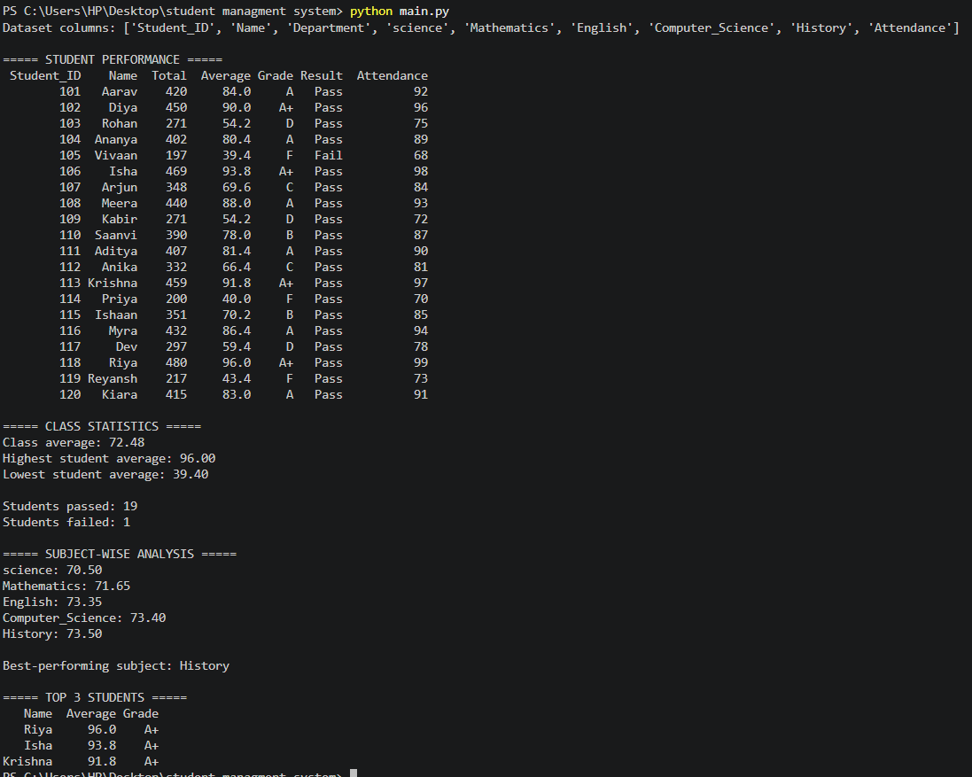
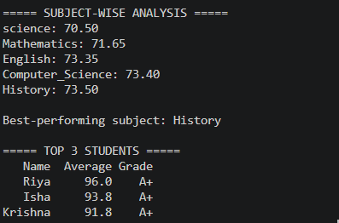
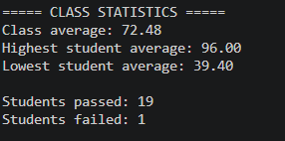
Final Outcome
The Student Performance Analytics System successfully achieves all functional and analytical requirements outlined by EWB Courses. By leveraging Pandas for tabular data management and NumPy for vectorized numerical computations, the application delivers rapid, error-free academic evaluations.
Key achievements of the project include:
- Flawless execution of data ingestion and automated metric calculations across 20 student records.
- Clear identification of cohort academic standing, demonstrating a robust class average of 72.48%.
- Accurate identification of academic achievers (led by Riya with an exceptional 96.00% average) and students requiring additional academic support.
- Demonstration of clean, modular, and maintainable Python programming practices suitable for engineering and data science applications.

Challenges and Learning
Challenges Faced:
- Dataset Formatting & Alignment: Ensuring that column names in students.csv matched exactly with the key strings expected by the Pandas aggregation functions in main.py required careful validation.
- Conditional Pass/Fail Logic: Implementing a robust row-wise condition to verify that every subject met the minimum threshold of 35 marks rather than relying solely on the aggregate average.
Key Learnings:
- Gained hands-on proficiency in utilizing Pandas DataFrames for filtering, summing, and computing statistical metrics.
- Learned how to integrate NumPy array operations seamlessly with Pandas series for high-performance numerical analysis.
- Understood the importance of writing modular, reusable Python functions with clean variable naming and descriptive comments.

GitHub Repository
The complete project files, including main.py, students.csv, README.md, and this documentation report, have been organized and pushed to a dedicated GitHub repository as required by EWB Courses.
Repository Link:
https://github.com/ADITYA402-make/student-performance-analytics/tree/main

